CONFERENCE AND SEMINAR PREMISES IN BAUSKA REGION

MAZMEŽOTNE MANOR ****  Mazmežotne,  Rundāles pag., Bauskas nov.  M. +371 25772269  E-mail: info@mazmezotne.lv   www.mazmezotne.lv /mazmezotne |  |  | Outside view  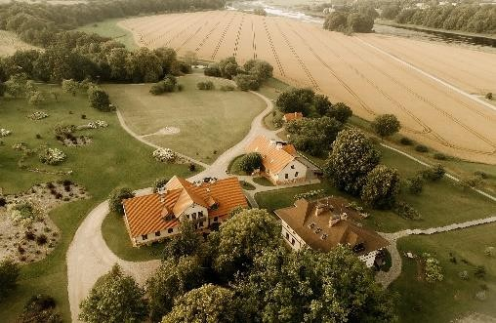 |  |  |  | Indoor view  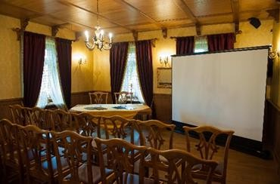 |  |  | Accommodation::  Hotel **** 19 rooms / 55 accommodation places  8 Double LUX suites: starting from 140 EUR  6 Double rooms with seperate beds: starting from 120 EUR 5 Family suites ( 3-4 beds): starting from 150 EUR  Holiday house „Siernīca” (7 beds): 450 EUR Additional extra bed: 35 EUR/pers.
 |  |  | Event shed  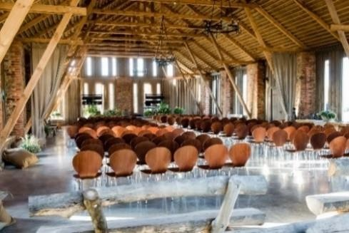 |  |  |  | Event stable  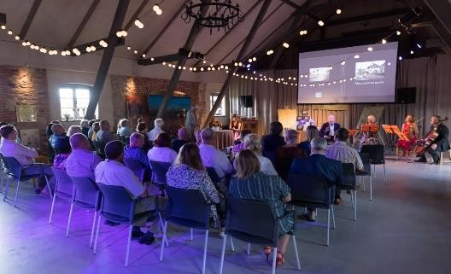 |  |  | Catering:  Coffee break: starting from 10 EUR/pers. (coffee, tea, milk, sugar, water, snacks);  Lunch break: starting from 35 EUR/pers. (3 course meal – snacks, main course, dessert, drink, coffee or tea);  Dinner: starting from 45 EUR/pers. (3 course meal – snacks, main course, dessert, drink, coffee or tea);  Breakfast: starting from 18 EUR/pers.
Room | Area, m2 | Maximal capacity in room layouts |  |  |  |  | Room price, EUR |  | Equipment (included in  price) |  | Additional options
Room | Area, m2 | Reception | Theater | Class | U-  shape | O-  shape | day | hour
Banquet hall | 55 | 45 | 45 | 45 | 30 |  | 600 | From 90 | Wi-Fi, Flip-chart board with paper, pen/marker, extenders.  Stage, additional lightning – only by prior arrangement! |  | Projector, retractable screen and table (2m x 2m) | 60 EUR
Vaulted hall | 30 | 30 | 30 | 30 | 30 |  | 400 | 60 |  |  | Projector, retractable screen and table (2m x 2m) | 60 EUR
Fireplace  lounge | 25 | 15 | 15 | 15 |  |  | 300 | 50 |  |  | Built-in screen (3m x 4m), projector | 80 EUR
The Event Shed – Concert Hall (From May to September) Event Stable- Concert Hall (Throughout  the year) | 350  250 | 500  300 | 400  200 | 300  100 | 250  100 |  | 1000  1000 | 170  170 |  |  | Built-in screen (3m x 4m), projector | 80 EUR

Special offer: | For the event manager - catering, accommodation with a 20% discount.
Special entertainment activities: | Active recreation offers - bicycle, boat rental. Sauna house, hot tub rental. Spa offers.  Concerts and exhibitions in the event barn and event stable of the manor.  Walking trails in the garden and along the manor for manor’s hotel clients and event guests – by prior arrangement!

RUNDĀLE PALACE  Pilsrundāle, Rundāles pag., Bauskas nov.  M. +371 26499151  E-mail: booking@rpm.gov.lv   www.rundale.net   /RundalePalace |  |  |  | Outside view  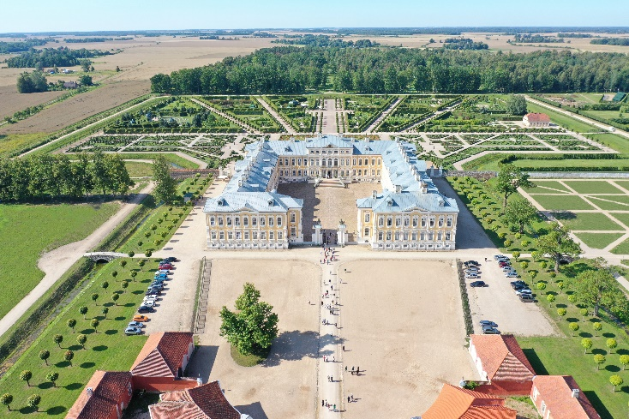 |  |  |  | Indoor view  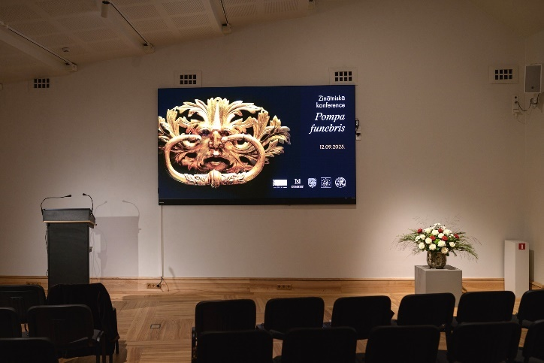 |  |  | Accommodation:  - Mazmežotne manor: www.mazmezotne.lv  - Guest house "Baltā māja"  www.hotelbaltamaja.lv
Catering:
- Café in palace "Ozollāde"
(M. +371 29105356)
- Café "Pils Krogs" (M. +371 29224624)
- Restaurant ‘’Rezidence’’
(M. +371 27009500)
- Guest house "Baltā māja"
M. +371 29121374
- Café “Grāfs” (M. +371 27308050)
- Café ”Zem zelta vāzes” (located in the French Garden, open during the summer season,
M. +371 2666085)
Room | Area, m2 | Maximal capacity in room layouts |  |  |  |  |  | Room price, EUR |  | Equipment (included in  price) | Additional options
Room | Area, m2 | Reception |  | Theater | Class | U- shape | O- shape | Day (8h) | Hour | Equipment (included in  price) | Additional options
Conference Centre Hall (Stable Building No. 2) | 109,7 |  |  | 100 |  |  |  |  | 200,00 | LED screen with speakers, chairs | Service available all year round
Conference Centre Exhibition Hall (Stable Building No. 2) | 105,9 | 120 |  | 100 |  |  |  |  | 105,00 | Service available all year round | Service available all year round
Banquet Hall | 148 | 100 |  | 100 |  |  |  |  | 120,00 | Designed as a reception hall (for snacks, coffee breaks) | Service available all year round
Coffee Hall | 57,5 | 20-30 |  |  |  |  | 15-20 |  | 110,00 | Style chairs, table | Service available all year round
Banquet Hall Complex (3 Halls) | 297,5 | 100 | 100 |  |  |  |  |  | 250,00 | Style chairs, table | Service available all year round
Hearth Hall | 133,1 | 120 | 120 |  |  |  |  |  | 200,00 | Service available all year round
Study Room | 24,75 |  | 25-40 |  |  |  |  |  | 70,00 | Projector, screen, TV, conference chairs | Service available all year round
Golden Hall | 225 |  | 200 |  |  |  |  |  | 720,00 | Style chairs | Service available only outside the active tourist season or outside the palace’s opening hours
White Hall | 308 |  | 200 |  |  |  |  |  | 600,00 | Style chairs | Service available only outside the active tourist season or outside the palace’s opening hours
Mežotne Palace | Each event is evaluated individually, depending on the room availability suitable for the occasion.
Special entertainment activities: | Theatrical guest welcome and guided tour (IU “Eleana”, Tel. +371 29108396, Email: jelena@ceremonija.lv)  18th-century-style guided tour with Olaf (Tel. +371 29902006, Email: olafs10@inbox.lv)  Electric vehicle ride through the palace garden (IK “Somnium”, Tel. +371 29169034, Email: peteris.grabovskis@gmail.com, available from May to October)  Guided tour of the palace (booking@rpm.gov.lv, Tel. +371 26499151)  Radio device rental available locally (Service provider: Olaf Soloveika, Tel. +371 29902006, Email: olafs10@inbox.lv).  Tickets for the palace exhibition must also be purchased according to the official public service price list approved by the Cabinet of Ministers or at www.rundale.net

BAUSKA CASTLE  Bauska castle museum Pilskalns, Bauska  Ph. 63923793 or M. +371 20011880  E-mail: bauskaspils@bauskasnovads.lv    bauskaspils.lv  /bauskaspils |  |  | Outside view  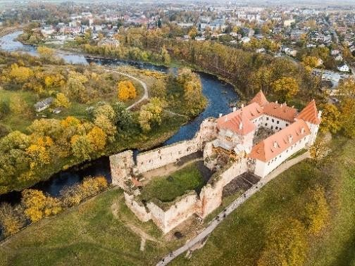 |  |  |  | Inside view  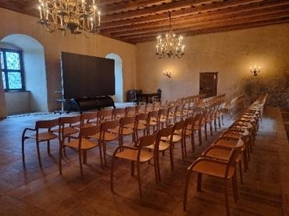 |  |  | Accommodation:  In Bauska castle (M. + 371 20011880)  Artist Residence – for musicians, artists, architects, researchers, restorers, conference participants from Latvia and foreign countries. 6 rooms available, which accommodate up to 12 guests.  Price: 12,10 EUR (including VAT) / per 24 hours
Catering:
A food service provider of client’s choice. Available premises for catering services during the event.
Room | Area, m2 | Maximal capacity in room layouts |  |  |  |  | Room price, EUR |  | Equipment (included in price) |  | Additional options
Room | Area, m2 | Reception | Theater | Class | U-  shape | O-  shape | day | hour
Conference hall | 150 | 130 | 130 | 130 | 130 | 100 |  | 133,10 EUR  (including VAT) | Conference chairs, tables, Wi-Fi |  | Setting up the event place before and after event (per hour) | 24,20 EUR  (including VAT)
 |  |  |  |  |  |  |  | 66,55 EUR  (including VAT) –  each next hour |  |  | Fee for supervision of museum premises, inventory and exhibits,  1 supervisor per 1 hour | 24,20 EUR  (including VAT)
 |  |  |  |  |  |  |  |  |  |  | Projection set (pc computer, projector, projector desk, LED video screen LP Display 200cm x 360cm | 36.30 EUR  (including VAT)
 |  |  |  |  |  |  |  |  |  |  | Audio system | 24,20 EUR  (including VAT)
 |  |  |  |  |  |  |  |  |  |  | Premises for catering services during the event | 72,60  EUR/1h (including VAT)
Special entertainment activities: |  |  | Bauska castle tour: 25 EUR (35 EUR ENG, RUS)  „ Dressing culture of the Duchy of Courland”: 30 EUR (40 EUR ENG, RUS)  „ Dance lesson in court”: 45 EUR (55 EUR ENG, RUS)  „ Renaissance time activities”: 30 EUR (40 EUR ENG, RUS)  "The Art of War in the 17th century. " 30 EUR ( 40 EUR ENG)

* If the time of the event is off the working hours of the museum, then the fee for monitoring the museum premises, inventory and exhibits is 24,20 EUR/ 1 h (including VAT)

BRUKNA MANOR  Brukna manor  Dāviņu pag., Bauskas nov. M.: +371 25619979  E-mail: brukna@brukna.lv   /Bruknasmuiža |  |  | Outside view  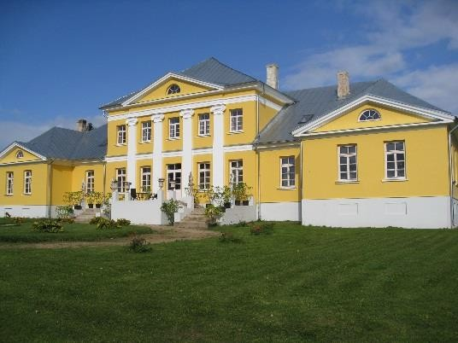 |  |  |  | Inside view  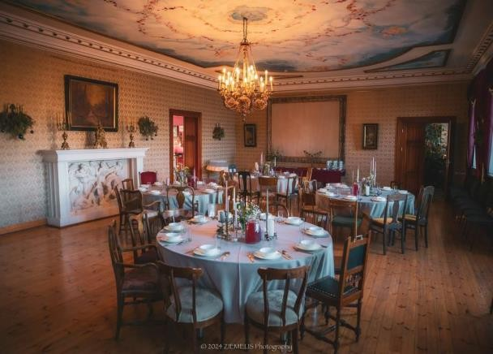 |  |  | Accommodation:  Up to 70 pers.  Price: starting from 18 EUR/pers.
Catering:
Breakfast: starting from 5 EUR/pers. Coffee break: starting from 2,50 EUR/ pers. Lunch break: starting from 6 EUR/pers.
Dinner: starting from 6 EUR/pers.
Room | Area, m2 | Maximal capacity in room layouts |  |  |  |  | Room price, EUR |  | Equipment (included in price) |  | Additional options
Room | Area, m2 | Reception | Theater | Class | U-  shape | O-shape | day | hour |  |  | Additional options
Main hall / Seminar hall | 110 | 200 | 150 |  | 60 | 70 | 350 | 50 | Wi-Fi, whiteboard, pen, projector. |  | Excursion through manor, walk in French garden.
Coffee room | 30 | 10 |  |  |  |  | 150 | 25 |  |  | Excursion through manor, walk in French garden.
Blue room | 35 | 6 |  |  |  |  | 150 | 25 |  |  | Excursion through manor, walk in French garden.
Dining room | 75 | 50 |  |  |  |  | 170 | 35 |  |  | Excursion through manor, walk in French garden.
Small fireplace lounge | 45 | 10 |  |  |  |  | 150 | 25 |  |  | Excursion through manor, walk in French garden.
Library | 25 | 6 |  |  |  |  | 150 | 25 |  |  | Excursion through manor, walk in French garden.
Special entertainment activities: |  |  | Sauna: 50 EUR/for evening

RECREATION COMPLEX  ROŽMALAS***  Nameju iela 2, Ceraukste, Ceraukstes pag., Bauskas nov.  M: +371. 26564580  E-mail: info@rozmalas.lv  www.rozmalas.lv /rozmalas    Rožmalas |  |  | Outside view  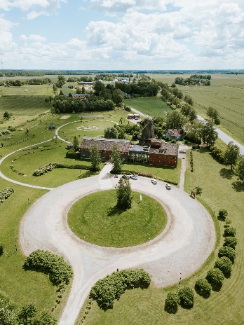  Conference room  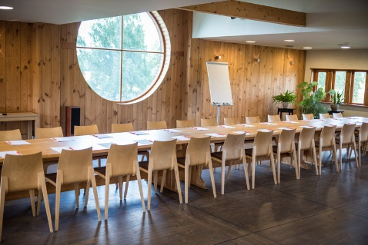 |  |  |  | Hotel  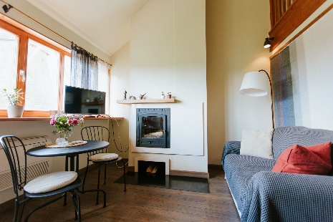  Restaurant  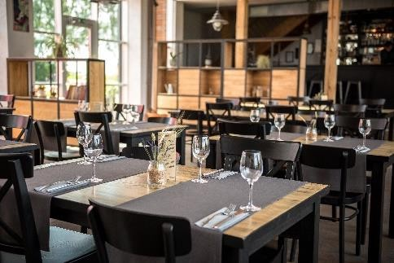 |  | Accommodation:  Hotel *** 17 rooms / 50 beds Standard single room: 40 EUR Double room: 65 EUR  Extra bed in a room: 20 EUR  *Prices include breakfast and 12% VAT
Catering:
Coffee break: starting from 10 EUR/pers. Lunch: starting from 18 EUR/pers.
Dinner: starting from 25 EUR/pers.
Room | Area, m2 | Maximal capacity in room layouts |  |  |  |  | Room price, EUR |  | Equipment (included in price) | Additional options
Room | Area, m2 | Reception | Theater | Class | U-  shape | Single  table | day | hour | Equipment (included in price) | Additional options
Seminar room | 140.6 |  | Līdz 150 | 56 | 26 | 30 | 140 | 30 | Wi-Fi, whiteboard, flipchart board, paper,  projector, pen, water
Small room | 35.4 |  | 20 |  |  | 20 | 80 | 20
Mill hall | 20 |  | 15 |  |  | 15 | 60 | 15
Special offer: |  |  | For the event organizer – a VIP room at the price of a standart room.
Special entertainment activities: |  |  | Tour in the Mill with pie baking: 7 EUR/pers. Tour with a common pretzel baking: 7 EUR/pers.  Tour in the Mill with pie baking and lunch soup: 12 EUR/pers. Sauna, jacuzzi: 30 EUR/h  Sauna complex: 100 EUR/h  Spacious parking for up to 100 cars

RECREATION COMPLEX MIĶELIS  ‘’Miķelis”  Gailīšu pag., Bauskas nov.  M. +371 26443496  E-mail: muzejs@mikelis.lv  www.mikelis.lv  /atputaskomplekss.mikelis |  |  | Outside view  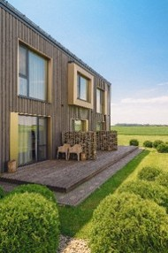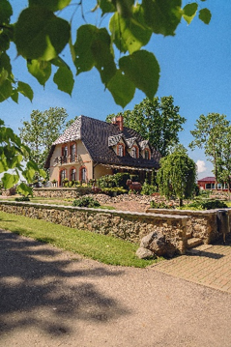 |  |  |  | Inside view  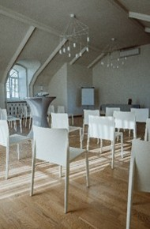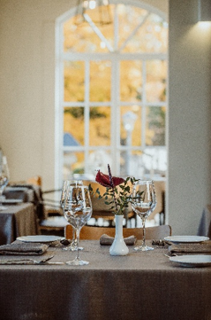 |  |  | Accommodation:  Hotel - Superior*** with 18 rooms and the capacity to accommodate up to 44 people using standard beds. With extra beds, the hotel can accommodate up to 63 people.
Catering:
Meals are provided at the resort's restaurant.
Coffee break: starting at 10 EUR per person.
Lunch: starting at 20 EUR per person.
Dinner: starting at 20 EUR per person.
Room | Area, m2 | Maximal capacity in room layouts |  |  |  |  | Room price, EUR |  | Equipment (included in price) | Additional options
Room | Area, m2 | Reception | Theater | Class | U-  shape | O-  shape | day (8h) | hour | Equipment (included in price) | Additional options
White hall | 70 | 90 | 90 | 50 | 60 | 30 | 260 | 35 | Tables, chairs, Wi-Fi, air conditioning | Projector, screen, flip chart, cabinet

GUEST HOUSE IECUPES  “Iecupes”, Iecava,  Bauskas nov.  M.: +371 20606055  E-mail : rgudlevskis@gmail.com  /iecupesviesunams |  |  | Outside view  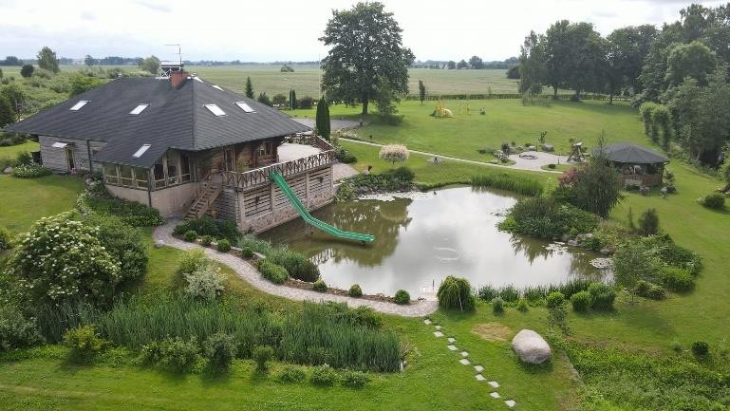 |  |  |  | Inside view  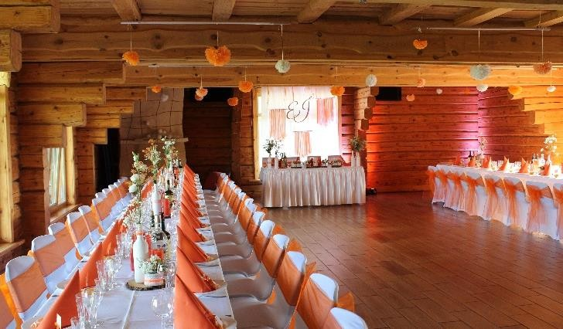 |  |  | Accommodation:  Up to 60 people (starting at 20 EUR per person)
Catering:
Cooperation with local caterers
Room | Area, m2 | Maximal capacity in room layouts |  |  |  |  | Room price, EUR |  | Equipment (included in price) |  | Additional options
Room | Area, m2 | Reception | Theater | Class | U-shape | O-shape | day | hour |  |  | Additional options
A complete set of guesthouse rooms | 110 | 90 |  |  |  |  | 500 | 70EUR/h (min.4h) | Wi-Fi, projector table, projector
Special entertainment activities: |  |  | Children’s playground, volleyball court – for free Sauna: from 60 EUR/day  Hot tub (for 4 pers.): from 60 EUR/day

CODE MANOR  Lielā iela 8,  Codes pag., Bauskas nov.  M.: +371 26187018 or +371 26467657  E-mail: anda.niedra@gmail.com /CodesMuiza/ |  |  | Outside view  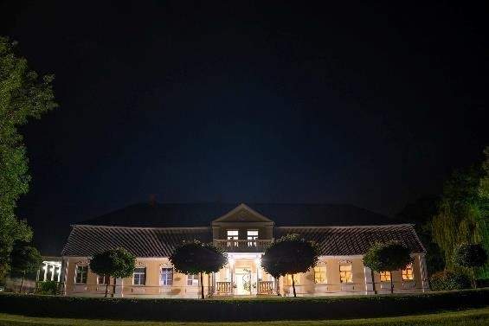 |  |  |  | Inside view  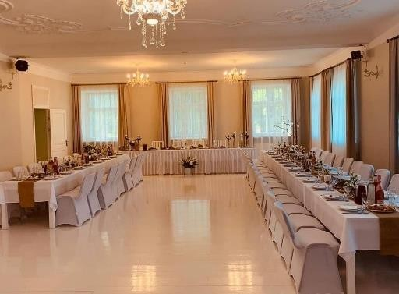 |  |  | Accommodation:  Up to 45 pers.  Additional accommodation places up to 8 pers. are available
Catering:
Cooperation with local caterers, for example, bistro “Rītausmas” - menu only by prior arrangement!
M. +371 26797278
Room | Area, m2 | Maximal capacity in room layouts |  |  |  |  | Room price, EUR |  | Equipment (included in price) |  | Additional options
Room | Area, m2 | Reception | Theater | Class | U-  shape | O-  shape | day | hour |  |  | Additional options
Central hall | 120 | 80 |  |  | 60 |  | Only by prior arrangement! Starting from 400 EUR | Only by prior arrangement! | Projector, computer, audio system, furniture, Wi-Fi |  | Available kitchen area (a room with an area of ~20m2), according to the customer's needs.  Tea, coffee table - prior arrangement!
Special entertainment activities and offer: |  |  | Excursion in the manor – free of charge!

THE MULTIFUNCTIONAL CENTER OF SOCIAL SERVICES “SARKANĀ SKOLA”  Bauskas iela 4, Vecumnieki, Bauskas nov.  M: +371 26681283 or +371 20299841  E-mail: liva.vecvanaga@bauskasnovads.lv  /SarkanaSkola |  |  | Outside view  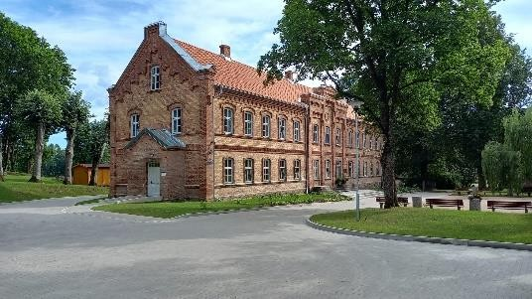 |  |  |  | Inside view  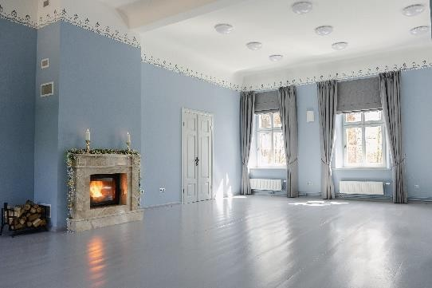  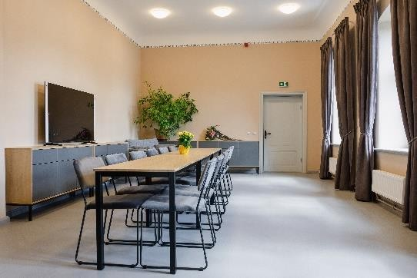 |  |  | Accommodation:  Otherplace in Vecumnieki  (more info - www.visit.bauska.lv)
Catering:
Cooperation with local caterers, for example, café “sĒdnīca” or pizzeria-café “Pie Martas un Marijas”)
Room | Area, m2 | Maximal capacity in room layouts |  |  |  |  | Room price, EUR |  | Equipment (included in price) |  | Additional options
Room | Area, m2 | Reception | Theater | Class | U-shape | O-shape | day | hour |  |  | Additional options
Fireplace lounge | 96,7 | 70 | 70 | 50 | 40 | 50 |  | 18,15  (without VAT) | Wi-Fi, whiteboard, computer, projector, flip-chart board, TV, adjustable screen, 360 video camera |  | A fireplace function is possible in the fireplace lounge.
Small seminar room | 38,9 | 20 | 15 | 15 | 15 | 15 |  | 6,66  (without VAT) |  |  | A fireplace function is possible in the fireplace lounge.
Art room No. 25 | 38,7 | 20 | 15 | 15 | 15 | 15 |  | 6,66  (without VAT) |  |  | A fireplace function is possible in the fireplace lounge.
Youth room No. 30 | 38,4 | 15 | 15 | 15 | 15 | 15 |  | 6,66  (without VAT) |  |  | A fireplace function is possible in the fireplace lounge.
Small meeting room  No. 29 | 21,9 | 5 | 5 | 5 | 5 | 5 |  | 6,66  (without VAT) |  |  | A fireplace function is possible in the fireplace lounge.
The service is available on working days during the institution’s working hours.

RIJA BAUSKA HOTEL  Slimnīcas iela 7, Bauska  Bauskas nov.  M. +371 29999272  E-mail: info.bauska@rijahotels.com   www.rijahotels.com |  |  | Outside view  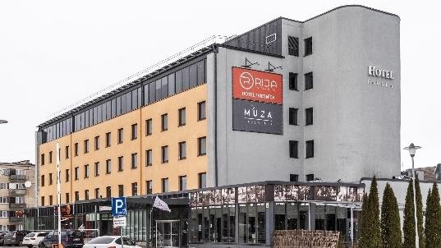 |  |  |  | Inside view  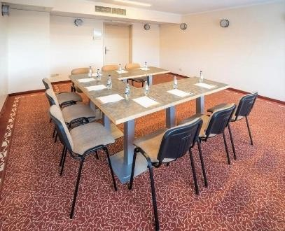 |  |  |  | Accommodation:  Standart single room: 40 EUR (including breakfast)  Standartt double room: from 50 EUR
Catering:
Coffee break: from 2.50 EUR-6EUR/pers.
Lunch/dinner with 3 course meal: from 15 EUR/pers.
Room | Area, m2 | Maximal capacity in room layouts |  |  |  |  | Room price, EUR |  |  | Equipment (included in price) |  | Additional options
Room | Area, m2 | Reception | Theater | Class | U-  shape | O-  shape | day | 2-4 h | Until 2h
Orange room | 33 | 20 | 20 | 12 | 15 | 12 | 50 | 35 | 20 | Wi-Fi, whiteboard, pen |  | Projector rental | 70 EUR/day
Blue room | 40 | 35 | 32 | 18 | 18 | 20 | 60 | 45 | 30 |  |  | Projector rental | 70 EUR/day
Banquet hall | 97 | 60 | 60 | 40 | 40 | 40 | 60 | 50 | 30 |  |  | Projector rental | 70 EUR/day

RUNDĀLE WATERMILL  Pilsrundāle, Rundāles pagasts,  Bauskas novads, LV-3921 M.: +371 20557777  E-mail: rundalesdzirnavas@gmail.com    www.rundalesdzirnavas.lv  /Rundalesudensdzirnavas |  |  | Outside view  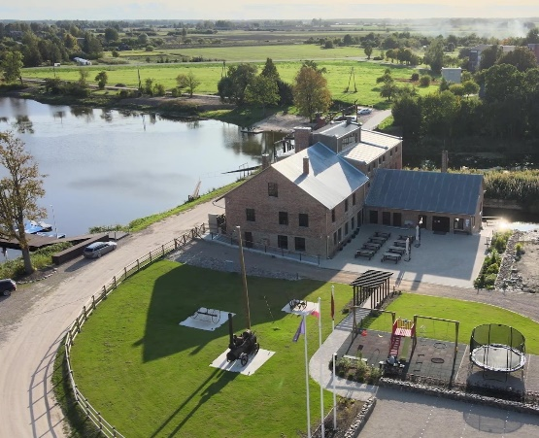 |  |  |  | Inside view  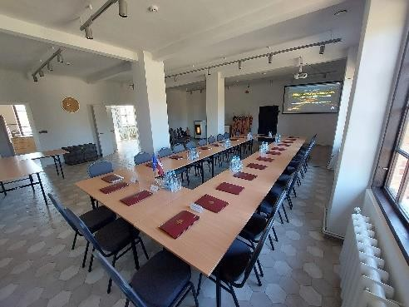 |  |  | Accommodation:  Closest place – Guest house “Baltā māja”  (~1 km away from watermill)
Catering:
Cooperation with local caterers (for example, restaurant “Rezidence” (M. 371 29121374), “Demors”(M. +371 26318788), “Baltā māja” (M. 29121374)
The buffet is coordinated and paid for additionally (the price must be agreed upon in advance).
Room | Area, m2 | Maximal capacity in room layouts |  |  |  |  | Room price, EUR |  | Equipment (included in price) |  | Additional options
Room | Area, m2 | Reception | Theater | Class | U-shape | O-  shape | day | hour |  |  | Additional options
Voldemārs’  hall | 79,3 | 50 (seatings) | 50 | 50 | 25 |  | 340 EUR | 2h (min. rental time) = 130 EUR;  Each next hour: 40 EUR | Water, tea, coffee, Wi-Fi, widescreen, multimedia projector, audio system,  extender, comfortable furniture. |  | Kitchen with the dishes is available (if the customer wants to invite his caterer)
Voldemārs’  hall | 79,3 | 40 (for wedding guests by round tables) |  |  |  |  |  | ~ 17:00-24:00 500  EUR un 500 EUR  security deposit. If the event is longer, each next hour: 100 EUR
Indulis’ room | 32,5 | Rest and make-up rooms are included in the price of the Voldemārs’ hall
Imants room | 7,5
Wardrobe | 26,4
Special entertainment activities and offer: |  |  | Visit in the museum – free of charge (for the guests of the event), for everybody else – visit in the museum and degustations are for  separate entrance fee.

PUB “AVEŅI”  Aveņmuiža, Bauska,  Bauskas nov.  Ph.: +371 63960150  E-mail: info@aveni.lv /krogsaveni |  |  | Outside view  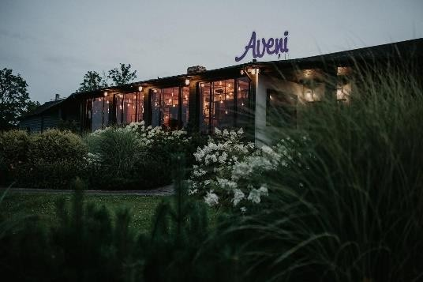 |  |  |  | Inside view  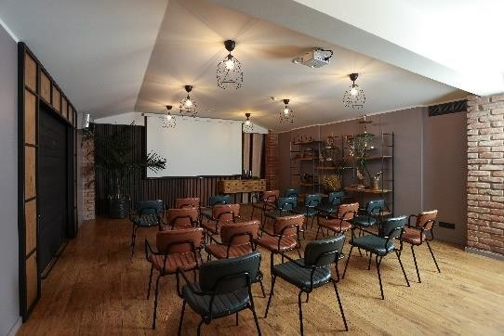  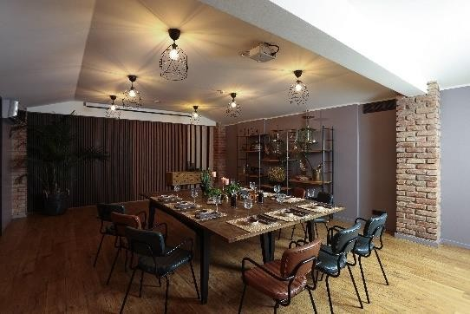 |  |  | Accommodation:  In Bauska town (more info: www.visit.bauska.lv)
Catering:

Is adapted to each client individually, taking into account the budget, format and number of people of the event - all after prior arrangement!
Room | Area, m2 | Maximal capacity in room layouts |  |  |  |  | Room price, EUR |  | Equipment (included in price) |  | Additional options
Room | Area, m2 | Reception | Theater | Class | U-shape | O-shape | day | hour |  |  | Additional options
Event room |  | Up to 40 pers. | Up to 40 pers. | Up to 20 pers. | 8-20  pers. | 8-20  pers. |  | 15 EUR | Screen, projector, table, chairs, other furniture
Room |  | Up to 40 pers.

BAUSKA MOTORMUSEUM  Derpeles iela 2, Bauska, Bauskas nov.  Ph.: +371 67025887  E-mail: bauskainfo@motormuzejs.lv   www.motormuzejs.lv /Bauskasmotormuzejs |  |  | Outside view  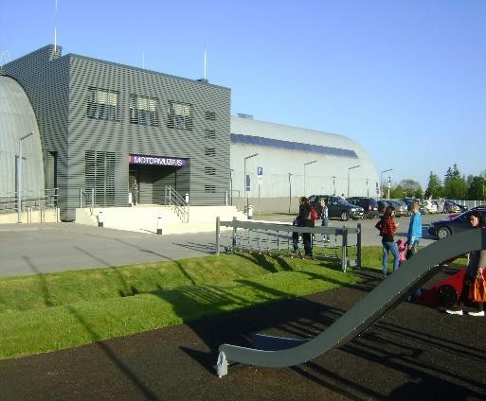 |  |  |  | Inside view  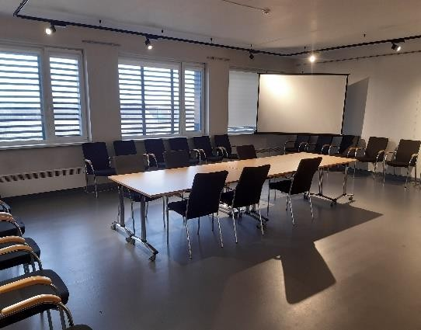 |  |  | Accommodation:  Otherplace in Bauska (more info: www.visit.bauska.lv)
Catering:
Pub “Aveņi” (across the street)
Room | Area, m2 | Maximal capacity in room layouts |  |  |  |  | Room price, EUR |  | Equipment (included in price) |  | Additional options
Room | Area, m2 | Reception | Theater | Class | U-shape | O-  shape | day | hour |  |  | Additional options
Conference room | 60 | 25 - 30 |  |  |  |  |  | 20 EUR | Wi-Fi, screen, projector, audio system, extender, whiteboard, tables, chairs. |  | The conference hall is also available for creative workshops for children (only by prior arrangement)!

YOUTH CENTER ”KLINTS”  Kurmene, Kurmenes pag., Bauskas nov.  M.: +371 20038364  E-mail: kjcklints@gmail.com /KJC5115 |  |  | Outside view  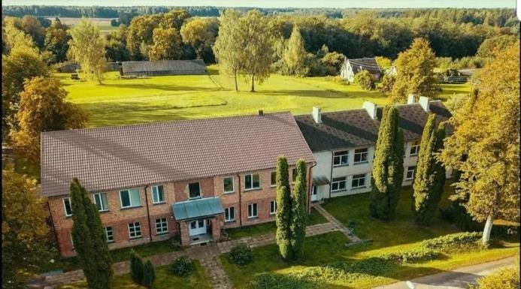 |  |  |  | Inside view  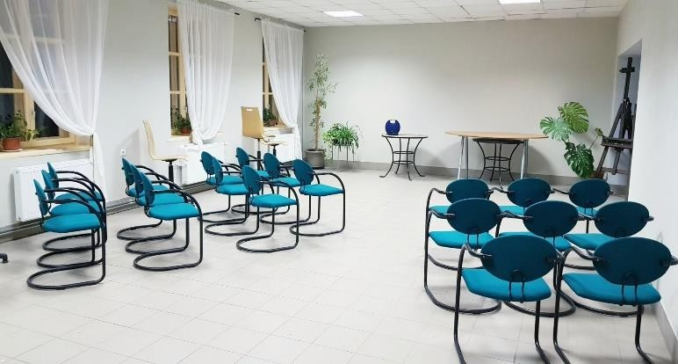 |  |  | Accommodation:  Up to 30 pers.  Price: from 25 EUR/pers.
Catering:
Breakfast: from 5 EUR/pers. Coffee break: from 2.50 EUR/pers. Lunch: from 6 EUR/pers.
Dinner: from 6 EUR/pers.
Room | Area, m2 | Maximal capacity in room layouts |  |  |  |  | Room price, EUR |  | Equipment (included in price) |  | Additional options
Room | Area, m2 | Reception | Theater | Class | U-shape | O-shape | day | hour |  |  | Additional options
Seminar room | 90 | 30 | 30 | 24 | 24 | - | 50 | 10 | + Catering room available Wi-Fi, flip-chart board, pen  Microphones, loudspeakers |  | Photo studio room rental: 15 EUR/h
Special offer: |  |  | Excursion “Through Kurmene church and manor complex” 1,5h up to 30 pers./ 30EUR
Special entertainment activities: |  |  | SUP board rental: 20 EUR/day  Bicycle rental: 15 EUR/day

GUEST HOUSE “LĪČUPES”  “Līčupes”, Iecava,  Bauskas nov.  M: +371 29219095 or +371 29144487  E-mail: licupes.iecava@gmail.com   /Laukumajas |  |  | Outside view  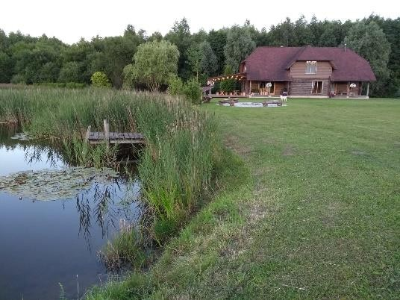 |  |  |  | Inside view  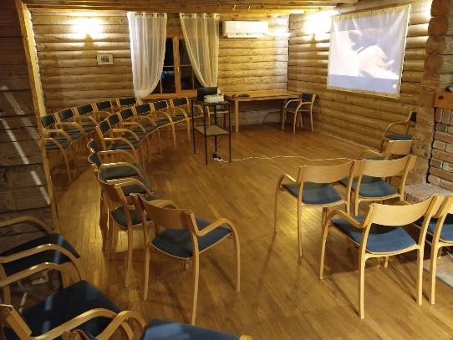 |  |  | Accommodation:  Overnight stay for up to 17 people  Overnight stay + €20 per person  Accommodation only (without conference hall rental): €150 for the whole house + €20 per person
Catering:
Cooperation with local caterers.
Room | Area, m2 | Maximal capacity in room layouts |  |  |  |  | Room price, EUR |  | Equipment (included in price) |  | Additional options
Room | Area, m2 | Reception | Theater | Class | U-shape | O-shape | day | hour |  |  | Additional options
Fireplace lounge | 50 | 35 |  |  |  |  | 250 |  | Wi-Fi, flip-chart board, projector  + screen
Special entertainment activities: |  |  | Kanoe boat rental: from 25 EUR/per boat/per day + transportation expenses Visit in the bee hive, honey production (up to 2 h), until 8 pers.: 50 EUR Sauna: 50 EUR  Programme “Latvian rituals” (1h/ 80-100 EUR), depending on the amount of persons  Fishing in the lake and in Iecava river (with own fishing stick)

“Rundāles Avoti” Business and Tourism Support Center  Pilsrundāle, Rundāles pag.  Bauskas nov.  T: 28343312  E-mail: uznemejdarbiba@bauskasnovads.lv  /uznemejdarbiba |  |  | Outside view  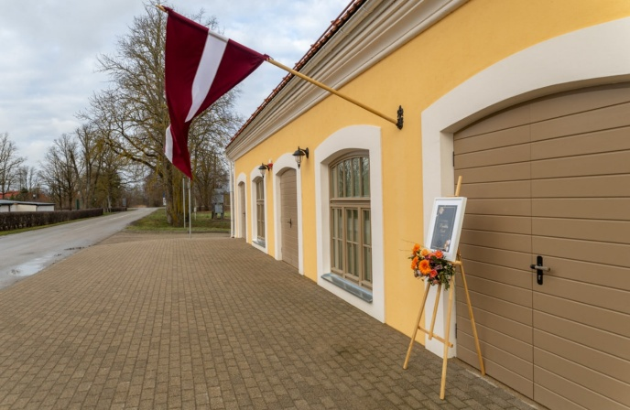 |  |  |  | Inside view  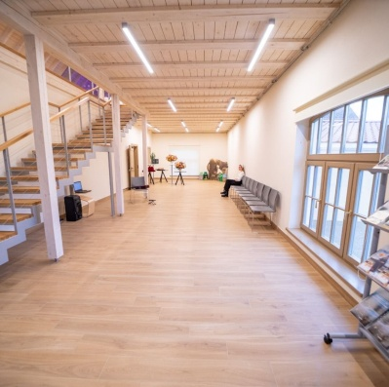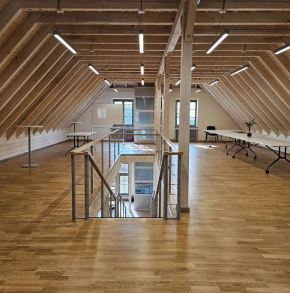 |  |  | Accommodation:  Overnight stay at the “Baltā māja” guesthouse (~0.1 km away) or elsewhere in Bauska
Catering:
Coffee break – to be arranged with the caterer of your choice
Room | Area, m2 | Maximal capacity in room layouts |  |  |  |  | Room price, EUR |  | Equipment (included in price) |  | Additional options
Room | Area, m2 | Reception | Theater | Class | U-shape | O-shape | day | hour |  |  | Additional options
2. floor hall | 103,4 | 30 |  |  |  |  | - | 18,56 | Wi-Fi, flip chart, projector, screen
- floor hall | 75 | 30 |  |  |  |  | - | 12,91
Special offer: |  |  | Option to apply for the service via the e-service - https://latvija.gov.lv/Services/51149

